**TERM 1 Yr 10 SCIENCE - GENETICS**

**GUIDLINES FOR MAKING STUDY NOTES**

*The headings below should be in your notebook. To make a good set of study notes, you should condense the learning that you have in your notebook for each of these headings.*

*In your study notebook put each of these heading at the top of a page. Use the guidelines below to make your study notes for each heading.*

*Use your notes to make the study notes, do not go to the internet unless desperate.*

1. **DNA** (1/2 page)

* Write definitions for DNA, gene, chromosome, trait, heredity, and karyotype.
* Explain the difference between DNA, gene, and chromosome
* Describe the basic structure of the DNA molecule
* List the names and symbols of the four bases in DNA.
* Copy this diagram of part of a DNA molecule and write in the missing bases

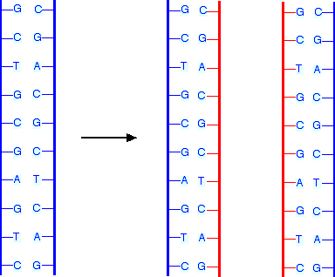

1. **MEIOSIS and GAMETES** (1/4 a page)

* Write definitions for meiosis, gamete (sex cells), fertilization, zygote, embryo, and mitosis.
* In one sentence explain the difference between mitosis and meiosis in terms of the diffenence in the cells these processes produce.
* In one sentence explain the difference between mitosis and meiosis in terms of how the process is useful to the organism.
* In one sentence explain why gametes are different to “normal” human cells.

1. **MONOHYBRID CROSSES** (3 pages)

* Define the terms allele, dominant, recessive, genotype, phenotype, homozygous (purebred), and heterozygous (hybrid), punnett square, pedigree, sex-linked.
* Explain why homozygous genotypes are called purebred, but heterozygous genotypes are called hybrid.

Monohybrid Crosses

* Copy or cut-n-paste the question below. Answer the question, showing full and correct working using a punnett square. Easy question

*In dogs, wire hair (S) is* [*dominant*](http://www.k-state.edu/biology/pob/genetics/defin.htm#dom) *to smooth (s). In a cross of a* [*homozygous*](http://www.k-state.edu/biology/pob/genetics/defin.htm#hom) *wire-haired dog with a smooth-haired dog, give the genotypes and* [*phenotype*](http://www.k-state.edu/biology/pob/genetics/defin.htm#phen)*s percentages of the* [*F1 generation*](http://www.k-state.edu/biology/pob/genetics/defin.htm#f1)*?*

* Copy or cut-n-paste the question below. Answer the question, showing full and correct working using a punnett square. Harder question.

*In Humans, normal pigmentation is due to a dominant allele (C), and albinism to its recessive allele (c). A normal man marries an albino woman. Their first child is albino. What are the genotypes of these three people? If there are more children, what would they probably be like?*

Pedigrees – Autosomal

* List the symbols used in a pedigree and what each symbol stands for
* 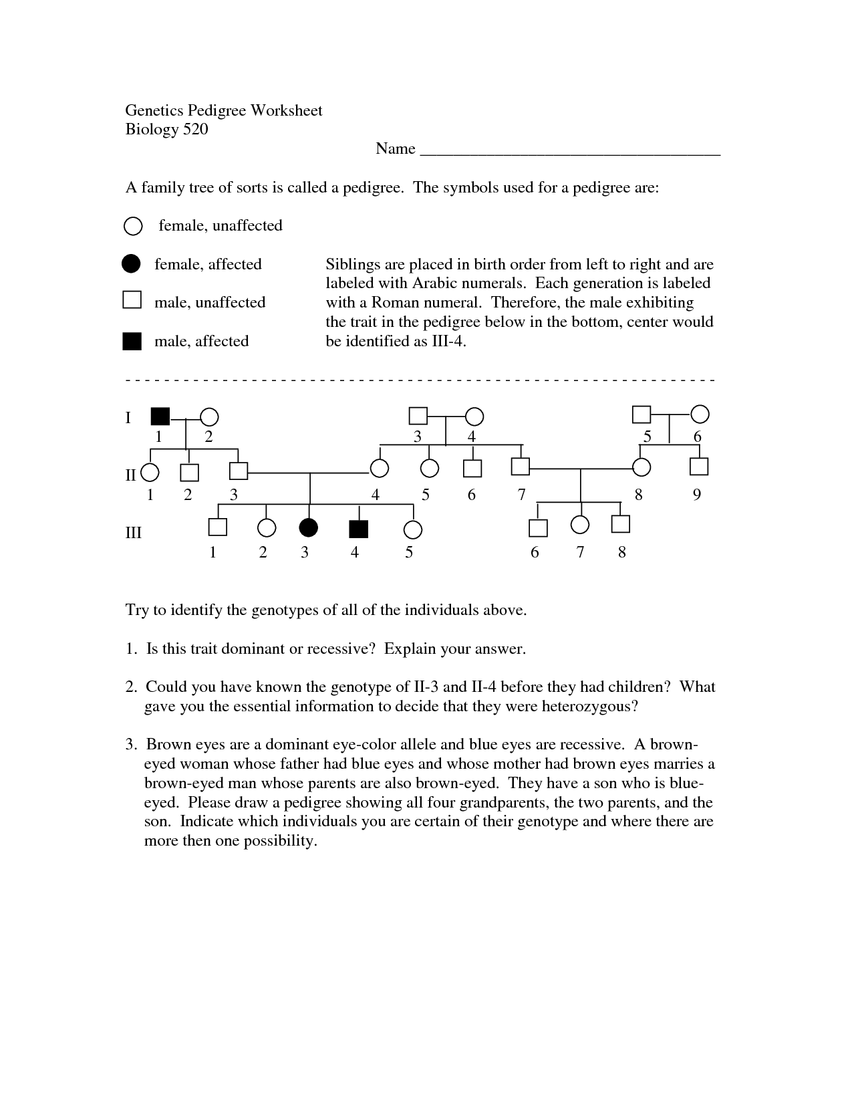Explain how to tell if a pedigree shows a “dominant” pattern of inheritance or a “recessive” pattern of inheritance.
* Copy or cut-n-paste the question below. Answer the question, showing full and correct working

Sex-linked crosses and pedigree (1 page)

* Define the term sex-linked inheritance
* Explain why a male will have only one allele for a sex-linked gene.
* Copy or cut-n-paste the question below. Answer the question, showing full and correct working

*The diagram on the right shows the inheritance of haemophilia – a sex-linked disease.*



4

10

9

8

7

6

5

16

15

14

12

13

11

1. *On the diagram write the possible genotypes for all of the individuals in the pedigree*
2. *If individuals 8 and 9 were to have another child, draw a punnett square to predict the possible genotype and phenotype of the child.*
3. **MUTATIONS (1/4 page)**

* Define the two mains types of mutations and explain what they are.
* List 3 factors which can cause mutations
* Explain how mutations can be beneficial, harmful, or not have an effect on an organism.

1. **THEORY OF EVOLUTION (1/2 page)**

* Define evolution, natural selection (survival of the fittest), biodiversity.
* Write down the five main points of Darwin’s Theory of evolution.
* Use Darwin’s theory to explain how kangaroos evolved from small mammals that crawled and climbed as Australia gradually warmed over thousands of years and forests died away and became open arid grassland.

1. **EVIDENCE FOR EVOLUTION (1/2 page)**

* List five types of evidence used to support the theory of evolution.
* For any three of these explain how that evidence provides support for the theory of evolution.